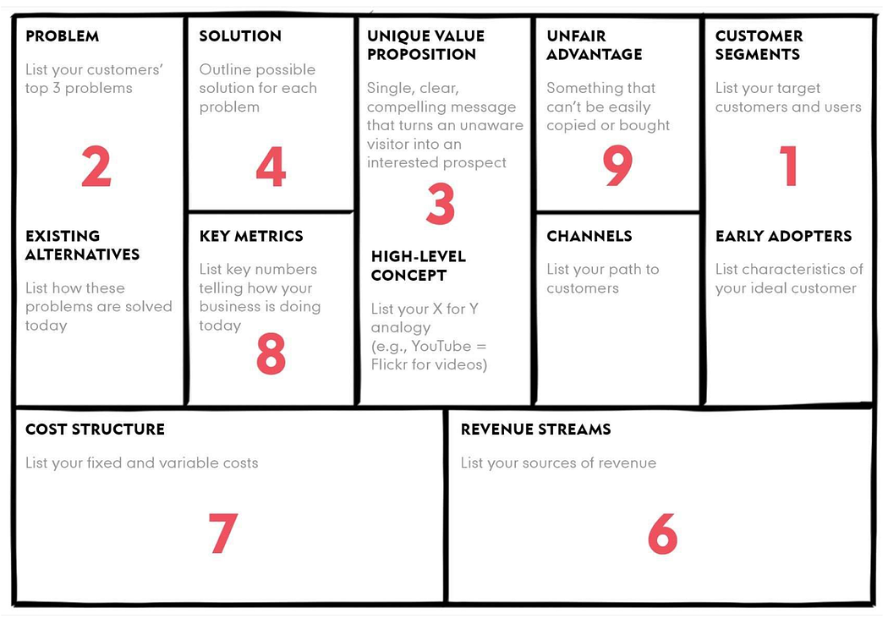
Lean Canvas by Ash Maurya adapted from Business Model Generation co-created by 470 practitioners from 45 countries

